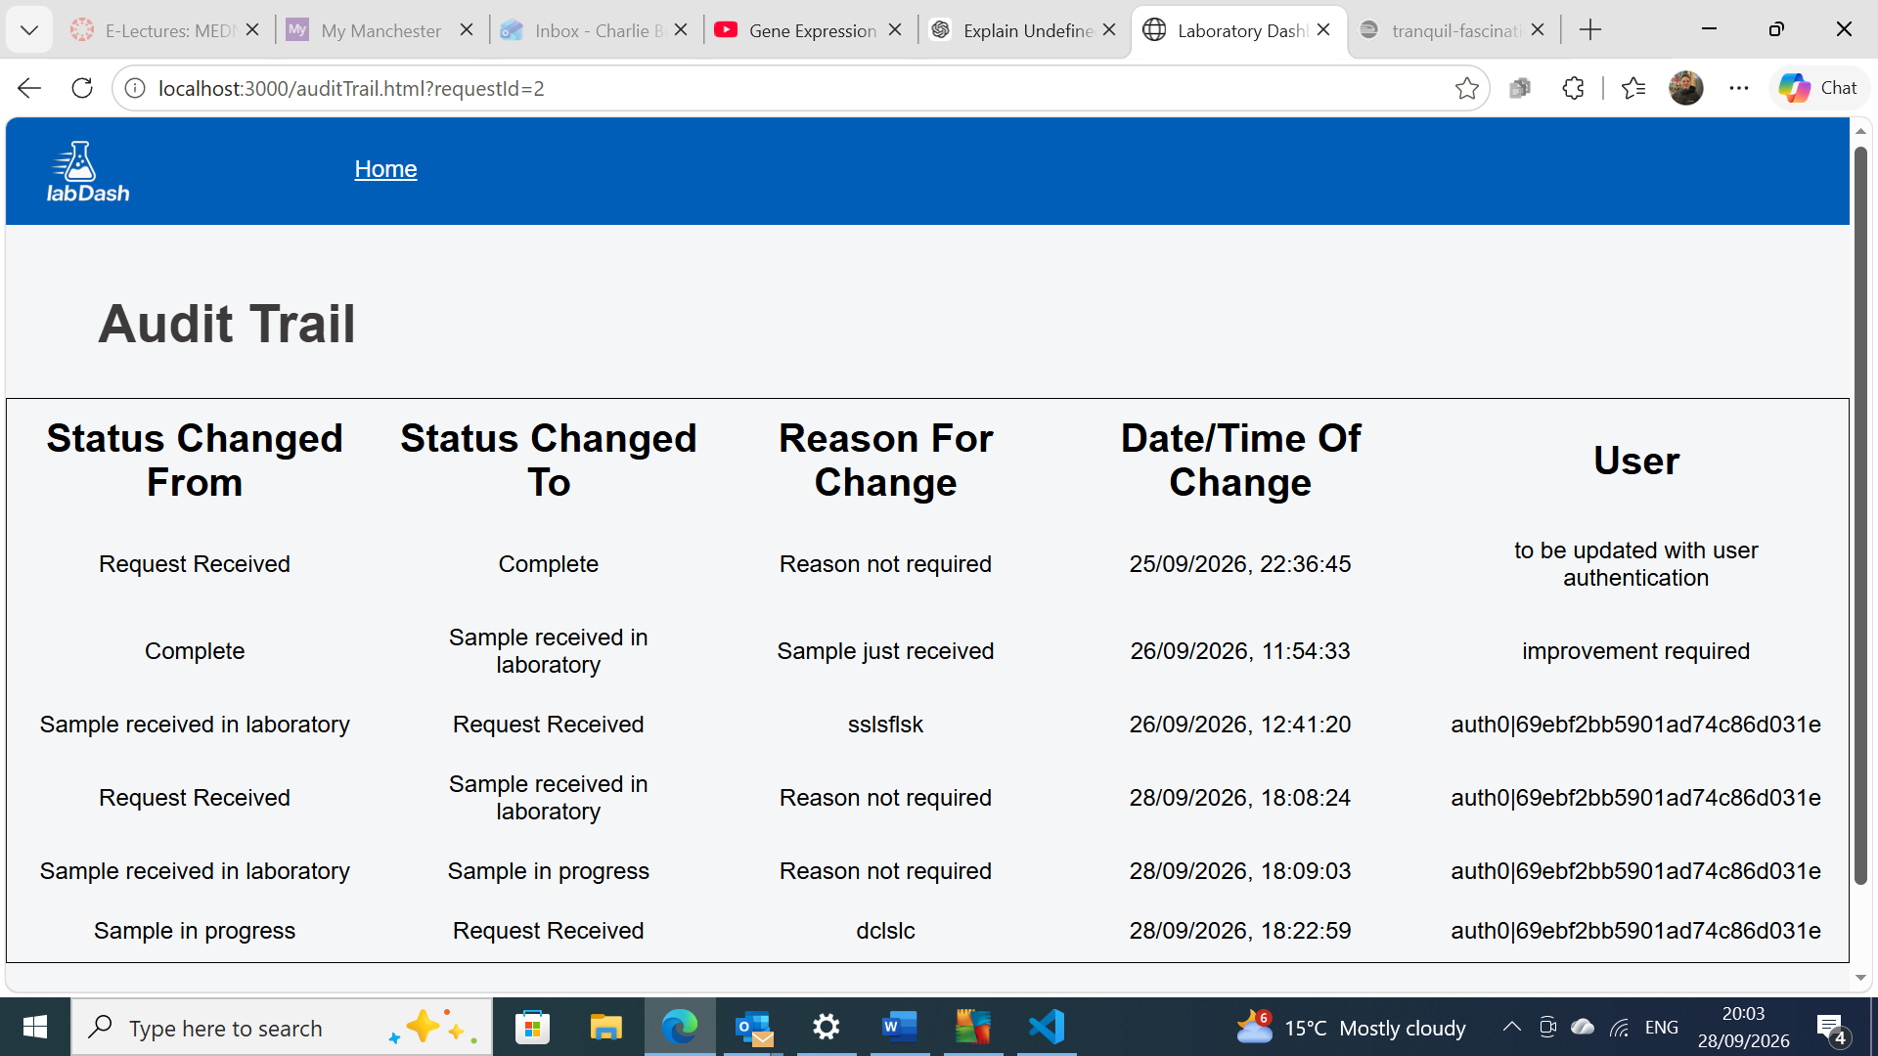
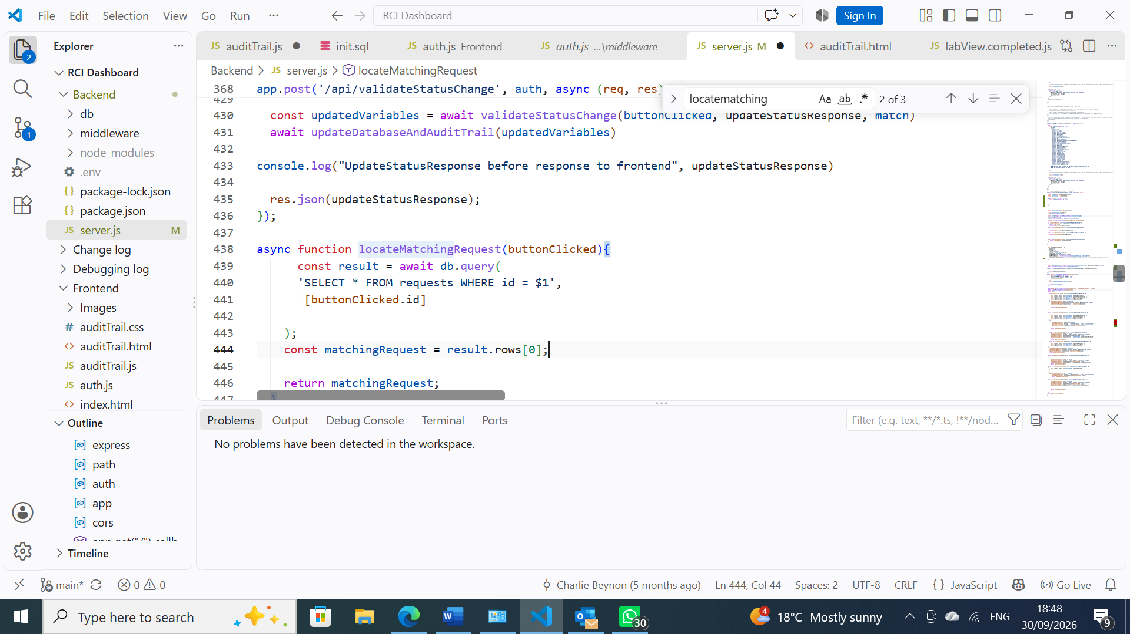

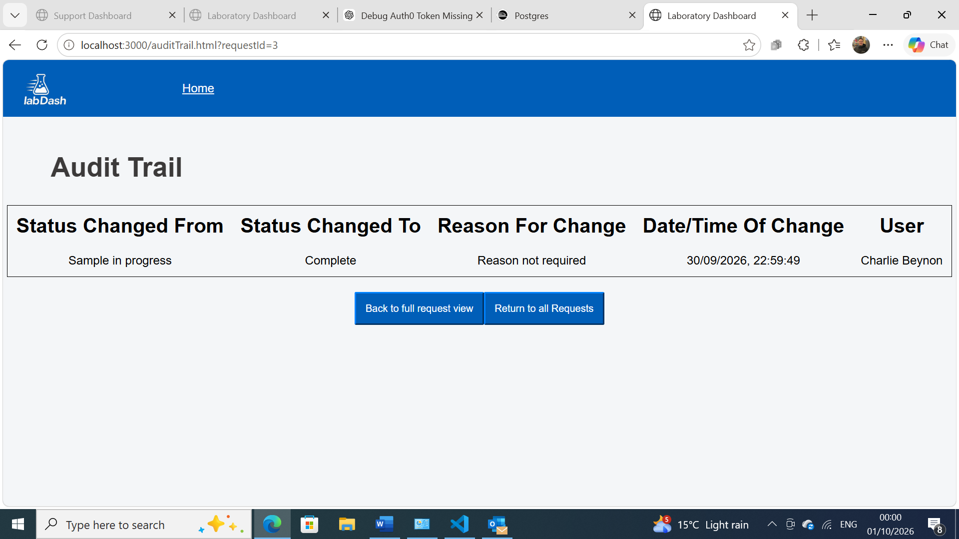

How many sample being sent?
Transplant information
Obstetric History - ?IUT
Attach panel results/lab results
Estimated completion time of request
Customer feedback – How long for request to be complete ?provide estimated completion time
Display of app on different devices

